***Assignment 3***

Use case: Vehicle registration process

***Activity 1 – Activity Diagram***

|  |
| --- |
| Use Case: Vehicle registration process |
| ID: 1 |
| Brief description: This process registers a vehicle |
| Primary actors: Driver/user of RoadRegistry |
| Secondary actors: Admin staff |
| Preconditions: none |
| Main flow:   1. Customer creates account or logs in 2. Clicks “register vehicle” 3. Customer is linked to form to input vehicle details before they hit submit 4. A message appears telling them they could wait up to 2 weeks for an answer confirming registration or detailing further requirements 5. Admin staff to check vehicle details, then deliver response and change vehicle status in customer account |
| Postconditions: Customer already has an account they can sign into |
| Alternative flows: Customer is denied registration or vehicle details are invalid for online registration, in which case they can speak to agent over the phone or log a ticket that results in online response. |

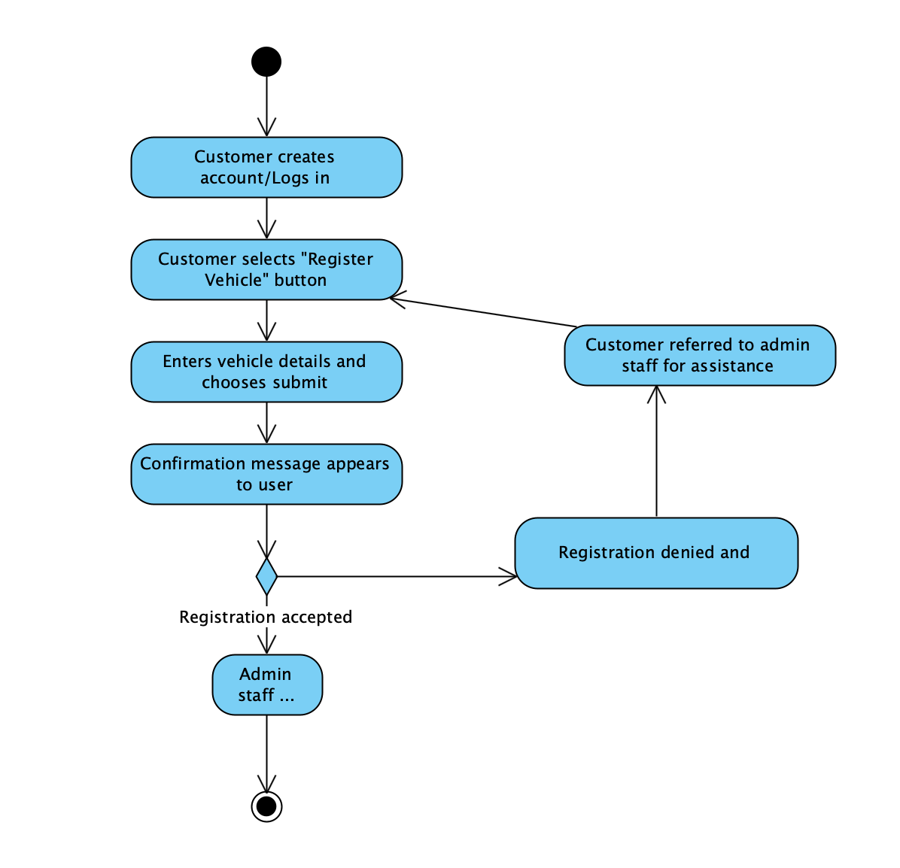

***Activity 2 – Sequence diagram***

***Activity 3 – Skeleton code***

//Driver class

import java.util.List;

Public class Driver{

private String firstName;

private String secondName;

private String licenceNumber;

private String email;

public void updateDetails();

public void registerVehicle();

public void payInvoice();

}

//Registration class

import java.util.List;

Public class Registration{

private String licencePlate;

private String registrationNumber;

private DateTime registrationTime;

public void updateRegistrationStatus();

public void checkSubmission();

}

//Admin class

import java.util.List;

Public class Admin{

private String employeeID;

private String specialty;

public void confirmRegistration();

public void denyRegistration();

public void contactCustomer();

}

//Vehicle class

import java.util.List;

Public class Vehicle{

private String licencePlate;

private String make;

private String model;

private DateTime year;

private bool isRoadWorthy;

public void sendRoadworthyTest();

public void decommission(); //changes isRoadWorthy to false

}